

Temperature and Humidity Investigation

SUBJECT: Weather variables and graphing.

GRADE LEVEL: 3rd to 5th

DEPTH OF KNOWLEDGE LEVEL: 2 and 3

AUTHOR: Dr. Lawrence Rudd, School of Education, Nevada State College, Lawrence.rudd@nsc.edu

NEXT GENERATION SCIENCE STANDARDS:

1. Represent data in tables and various graphical displays (bar graphs and pictographs) to reveal patterns that indicate relationships. (3-ESS2-1)
2. [Obtain and combine information from books and other reliable media to explain phenomena. (3-ESS2-2)](http://www.nap.edu/openbook.php?record_id=13165&page=74)
3. [Scientists record patterns of the weather across different times and areas so that they can make predictions about what kind of weather might happen next. (3-ESS2-1)](http://www.nap.edu/openbook.php?record_id=13165&page=186)
4. [Climate describes a range of an area's typical weather conditions and the extent to which those conditions vary over years. (3-ESS2-2)](http://www.nap.edu/openbook.php?record_id=13165&page=186)

PRIOR KNOWLEDGE: Students will know how to draw and interpret graphs. Students will be familiar with the weather variables of temperature and humidity and be able to define climate.

INTRODUCTORY ACTIVITY: Find definitions of weather, humidity, and temperature in a book or from an online source. Why do you think it is important to know these two weather variables? Watch a weather forecast for the place that you live. How does the weather forecaster describe the temperature and humidity when they give the weather forecast?

CONCEPT/SKILL DEVELOPMENT:

**Objective:**

The purpose of this investigation is to be able to read and interpret temperature and precipitation graphs. Given temperature and precipitation graphs of a site in Nevada, students will be able to compare these graphs to describe similarities and differences between these graphs and a climograph of the same site.

**Materials:**

Graphs of temperature and precipitation and a climograph from the Nevada Climate-ecohydrology Assessment Network (<http://sensor.nevada.edu/NCCP/Climate%20Monitoring/Network.aspx>).

**Important Terms:**

Temperature

Humidity

Relative Humidity

Hygrometer

Graph

**Diving question:**

What information about a place can be found on temperature and humidity graphs?

**Background Information**

Information about the weather is collected at weather stations which contain a variety of weather instruments. Two of those instruments are a thermometer used to measure temperature and a hygrometer used to measure relative humidity. A series of weather stations in an area is called a transect. Two transects were created in Nevada in 2011 to collect information about the weather in the Sheep Range in southern Nevada and the Snake Range in eastern Nevada.

Data from one of the stations in the Sheep Range transect was used to create the graphs you will examine in this investigation. This station is located in an area that is dominated by a plant called Blackbrush, so the station is named the Blackbrush Station. While it is useful to look at individual temperature and humidity graphs to understand the weather in a place, people who are interested in weather also create graphs that combine information on temperature and humidity on one graph. You will examine a graph with information on two vertical axes in the extension section of this investigation.

While you are working on the introductory activity, visit the site:

<http://sensor.nevada.edu/NCCP/Climate%20Monitoring/Equipment.aspx>

to examine both the instrumentation at each transect site as well as the location of the data transects themselves.

**Resources**

<http://sensor.nevada.edu/NCCP/Default.aspx>

The Nevada Climate Change Portal. This site explains the Nevada Climate Change project.

<http://eo.ucar.edu/webweather/basic1.html>

This site contains information on storms and weather variables such as precipitation.

<http://www.weatherwizkids.com/index.htm>

A site with lots of information about weather, including temperature, humidity, and climate.

<http://www.weatherwizkids.com/weather-words.htm>

A very thorough glossary of weather terms.

**Investigation**

1. Define the important terms for this investigation.
2. Examine the temperature and relative humidity graphs (Figures 1 and 2). How are these graphs similar? How are these graphs different?
3. What type of graph is the temperature graph?
4. At approximately what time during each day is the relative humidity the highest?
5. At approximately what time during each day is the temperature the highest?
6. Describe the pattern to how temperature and relative humidity change through this seven-day period.
7. Research relative humidity and temperature. Why do you think that the pattern you described in your answer to question 5 exists?

**Extension**

Now that you have looked over the temperature and humidity graphs included in this investigation, examine figure 3, which contains a graph that combines temperature and humidity information on one graph. Do you find the graph in figure 3 confusing or helpful? Why? Does the graph in figure 3 make it easier or more difficult to see how temperature and relative humidity change together during these seven days in June? Explain.

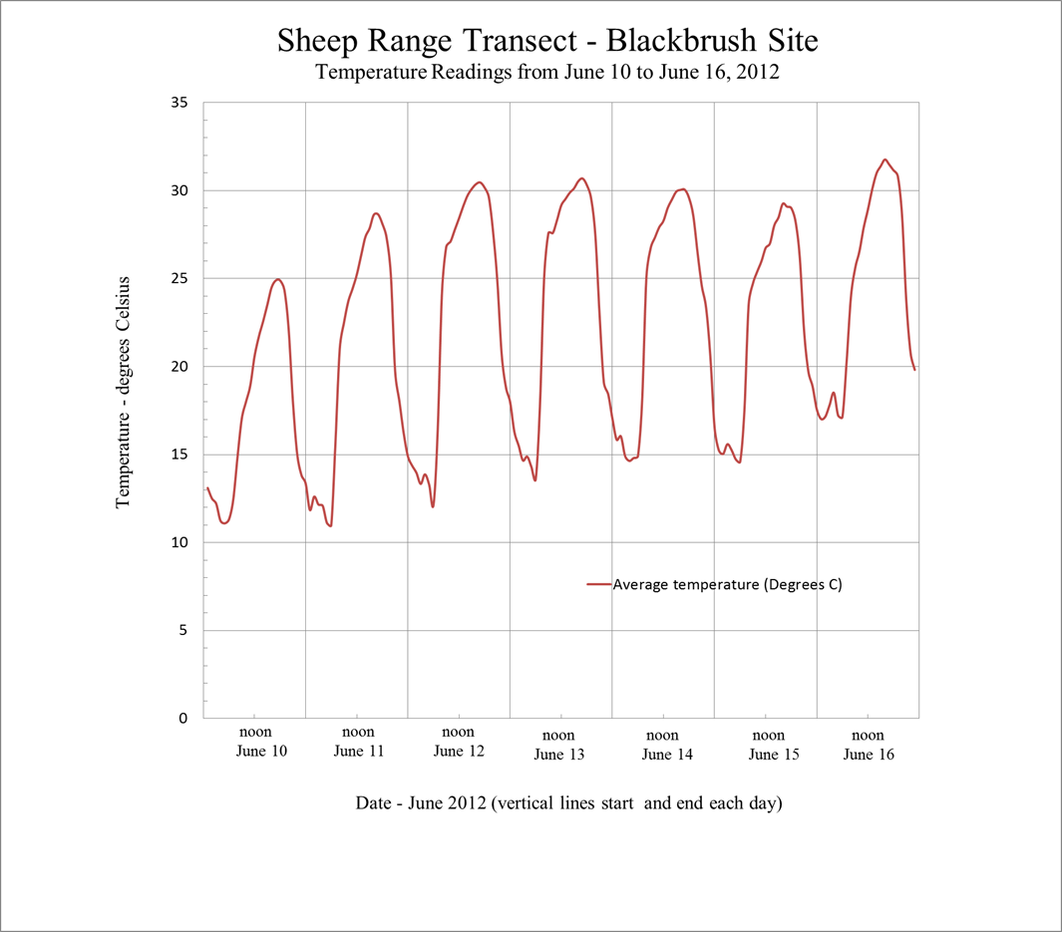

**Figure 1.** Hourly average temperature readings from June 10 to June 16, 2012 at the Blackbrush Station of the Sheep Range Transect, Nevada Climate-ecohydrology Assessment Network.

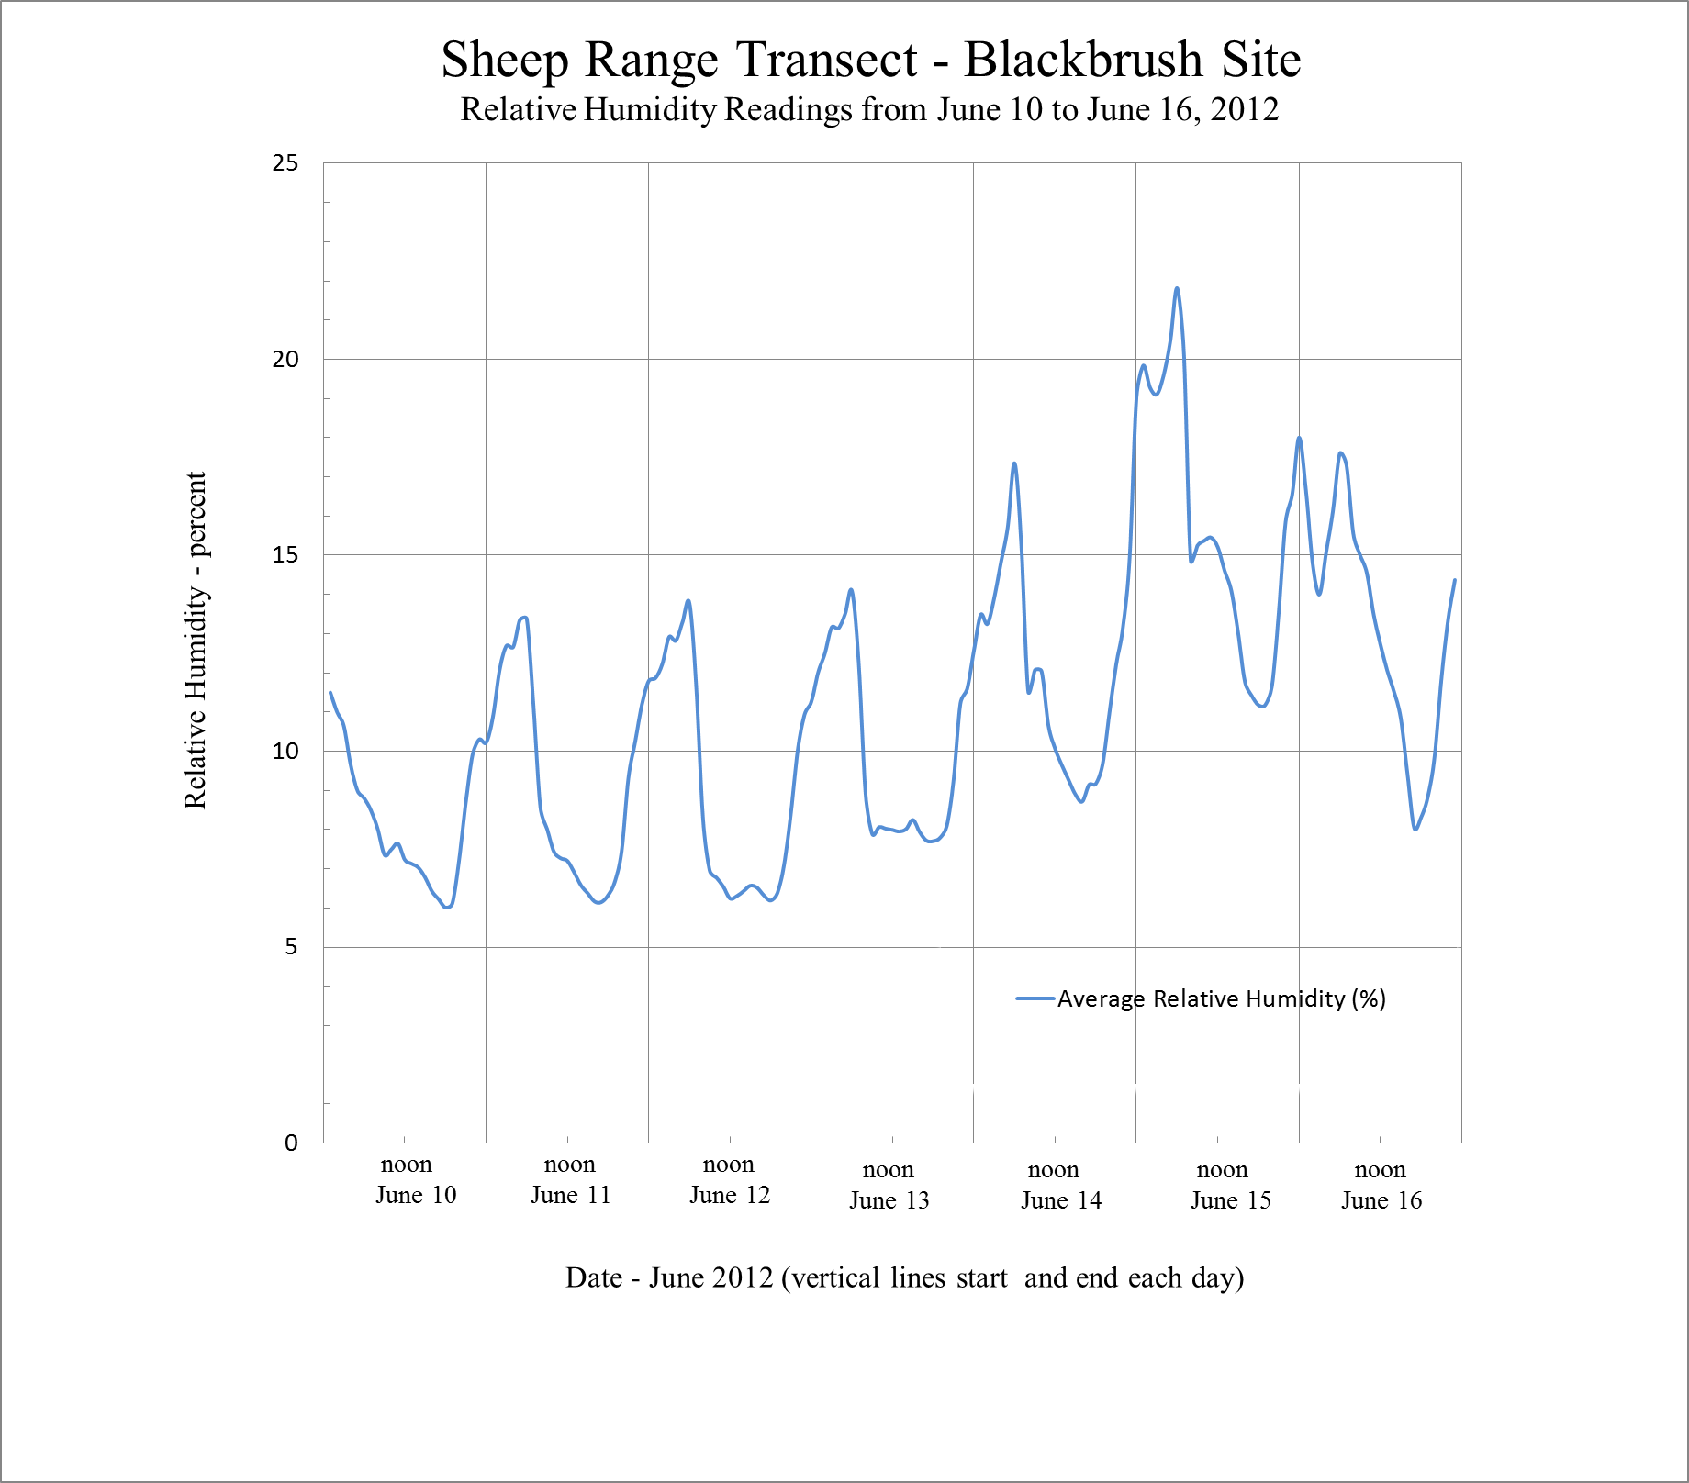

**Figure 2.** Hourly average relative humidity readings from June 10 to June 16, 2012 at the Blackbrush Station of the Sheep Range Transect, Nevada Climate-ecohydrology Assessment Network.

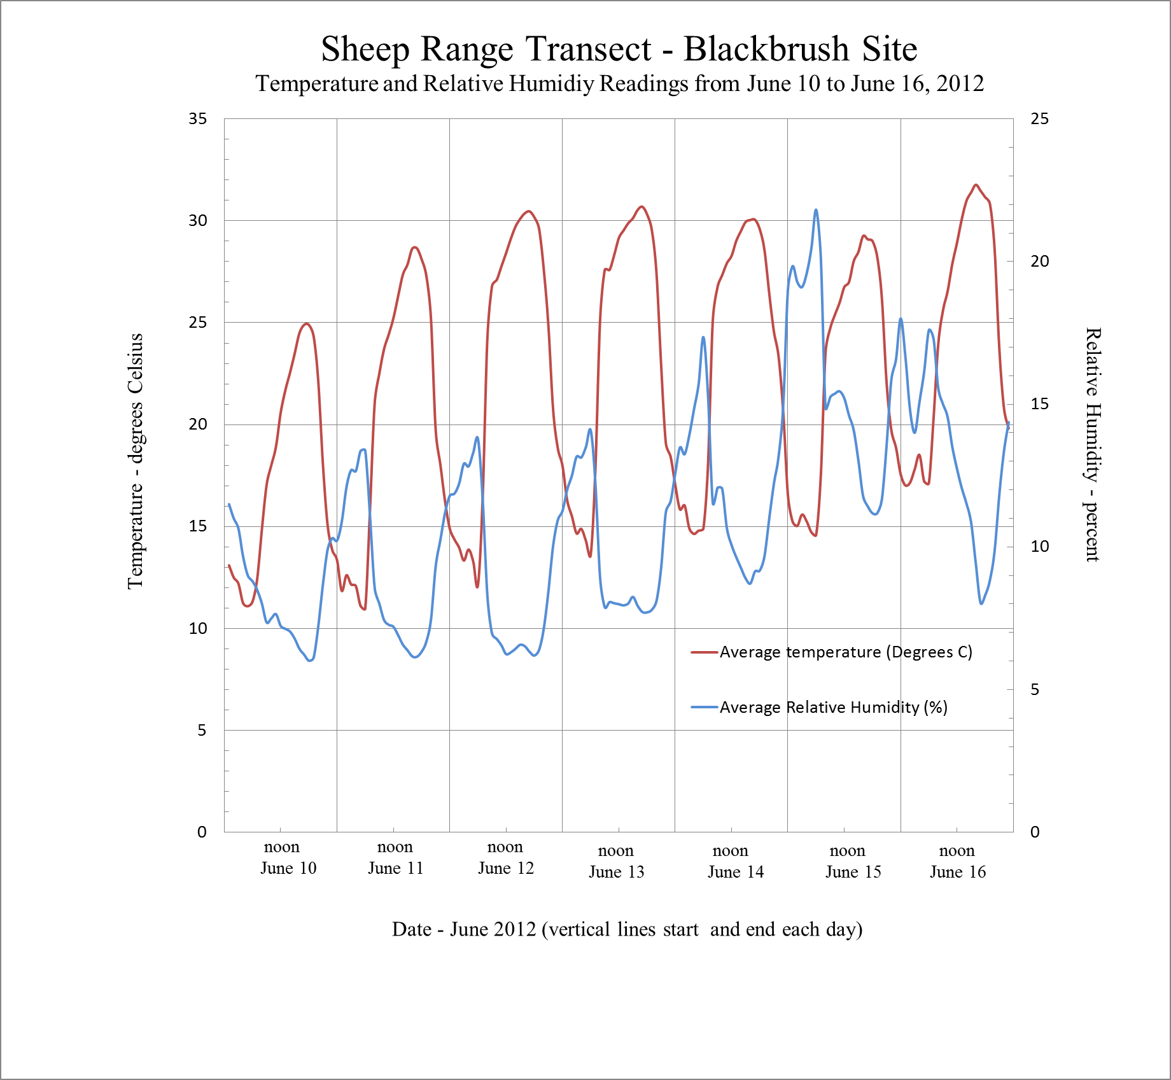

**Figure 3.** Plot of average hourly temperature and relative humidity readings from June 10 to June 16, 2012 at the Blackbrush Station of the Sheep Range Transect, Nevada Climate-ecohydrology Assessment Network.